|  |  |  |
| --- | --- | --- |
| Proof-of-Concept Integrated Work Zone Mapping Toolset | | |
| System Engineering and Testing |
| www.its.dot.gov/index.htm  **Final Report – July 13, 2020** |
| **Prepared for:**  **FHWA-JPO-20-815 V2X Work Zone Mapping Toolset** |
|  | |



Produced by ICF

U.S. Department of Transportation

ITS Joint Program Office – HOIT

Notice

This document is disseminated under the sponsorship of the Department of Transportation in the interest of information exchange. The United States Government assumes no liability for its contents or use thereof.

The U.S. Government is not endorsing any manufacturers, products, or services cited herein and any trade name that may appear in the work has been included only because it is essential to the contents of the work.

|  |  |  |  |  |  |  |
| --- | --- | --- | --- | --- | --- | --- |
| **Technical Report Documentation Page** | | | | | | |
| 1. Report No.  FHWA-JPO-XX-XXX | 2. Government Accession No. | | | 3. Recipient’s Catalog No. | | |
| 4. Title and Subtitle  System Engineering and Testing Plan For  Proof-of-Concept of Integrated Work Zone Mapping Toolset  Task 6 Technical Memo Draft | | | | 5. Report Date  07/13/2020 | | |
| 6. Performing Organization Code | | |
| 7. Author(s)  Denny Stephens (Vital Assurance), Tony English (Neaera Consulting), Deepak Gopalakrishna (ICF) | | | | 8. Performing Organization Report No. | | |
| 9. Performing Organization Name and Address  ICF International, 1725 Eye St NW, Washington DC, 20006  Neaera Consulting, 5819 Highland Hills Cir, Fort Collins, CO 80528  Vital Assurance, 175 S. Third St., Suite 200, Columbus, OH 43215 | | | | 10. Work Unit No. (TRAIS) | | |
| 11. Contract or Grant No.  DTFH61-16-D-00052 | | |
| 12. Sponsoring Agency Name and Address  U.S. Department of Transportation  Federal Highway Administration  Office of Operation R&D  1200 New Jersey Avenue, S.E.,  Washington, DC 20590 | | | | 13. Type of Report and Period Covered  Draft Report  9/2017-6/2020 | | |
| 14. Sponsoring Agency Code  HOIT-1 | | |
| 15. Supplementary Notes  Work performed for: Deborah Curtis (TOCOR), Harry Crump (COR), Beverly Appell (CO) | | | | | | |
| 16. Abstract  This report provides system engineering support for a project to develop, test and verify a proof of concept (POC) system for efficiently capturing a digital map of a work zone and its features, including lane closures and workers present in the work zone. These data are combined with other work zone configuration data to form a work zone map message that is published to disseminate to infrastructure owner-operator traveler information systems, third-party traveler information systems, and automated driving systems (ADS) such as the FHWA CARMA3 vehicle. The work zone map message is to be published in WZDx V2, SAE J2945/4 RSM (XML), and SAE J2945/4 RSM (binary) formats. This document summarizes system engineering architecture and requirements for the POC system as well as a testing plan. | | | | | | |
| 17. Key Words  Connected Vehicle Technology, System Architecture, System Engineering, Testing Plan, Work Zone Mapping | | | 18. Distribution Statement  This document is available to the public through the National Technical Information Service, Springfield, Virginia 22161 | | | |
| 19. Security Classif. (of this report)  Unclassified | | 20. Security Classif. (of this page)  Unclassified | | | 21. No. of Pages  35 | 22. Price |
| **Form DOT F 1700.7 (8-72) Reproduction of completed page authorized** | | | | | | |

Table of Contents

Chapter 1. Introduction 1

1.1 Background and Need 1

1.2 Objective 2

1.3 Concept and Approach 2

1.4 Document Purpose 2

1.5 Document Structure 2

Chapter 2. WZ Mapping Toolset POC System Architecture 3

2.1 Work Zone Mapping Use Case 3

2.2 WZ Mapping Toolset POC System Architecture 4

2.2.1 WZ Mapping Toolset POC System Components 5

2.2.2 TMC Website 5

2.2.2.1 Configuration Creator 6

2.2.2.2 Upload Page 6

2.2.2.3 Verification and Visualization 6

2.2.2.4 Published WZ Page 7

2.2.2.5 Azure Cloud Storage 7

2.2.2.6 Work Zone Data Collection (WZDC) Tool 7

2.2.2.7 Vehicle Path Data Acquisition 7

2.2.2.8 Message Builder 7

2.2.2.9 RSM(XML) -> WZDx Translator 8

2.2.2.10 RSM(XML) -> RSM(binary) Translator 8

2.2.3 Optional Testing Architecture using V2X Hub 8

Chapter 3. WZ Mapping Toolset POC Testing Requirements 10

3.1 Testing Requirements for Testing Work Zone 10

3.2 System Requirements 11

3.2.1 TMC Website 11

3.2.2 WZDC Tool 13

3.2.3 Authentication and security 15

3.2.4 Optional V2X Hub Addition 15

Chapter 4. WZ Mapping Toolset POC Agile Development Sprint 16

Chapter 5. WZ Mapping Toolset POC Demonstration and Testing Plan 17

5.1 Introduction 17

5.2 Demonstration Summary 17

5.3 Testing Summary 17

5.4 Testing Objective 18

5.5 Testing Approach 18

5.6 Testing Environment 18

5.7 Roles and Responsibilities 18

5.8 Testing Preconditions 18

5.9 Testing Schedule 18

5.10 Features for Testing 18

5.11 Testing Equipment 19

5.12 Safety Requirements 19

5.13 Testing Procedure 20

Chapter 6. Glossary 26

Chapter 7. References 27

List of Figures

Figure 1 Illustration of WZ Mapping Toolset POC Use Case for Capturing WZ Path and Configuration Data 4

Figure 2 Illustration of the components of the POC WZ Toolset 5

Figure 3. Illustration of Optional POC Configuration using V2X Hub. 9

List of Tables

Table 1. Testing Requirements – Testing WZ 10

Table 2. Testing Requirements – TMC Website. 11

Table 3. Testing Requirements – WZDC Tool 13

Table 4. Testing Requirements – Optional V2X Hub 15

Table 5. Feature and Development Lifecycle 16

Table 6. Testing Procedure 20

Table 7. Glossary 26

Table 8. References 27

# Introduction

## Background and Need

The Vehicle to Everything (V2X) Mapping Project focuses on the question of sharing of connected and automated vehicle (CAV) path data. The research question at the core of the project is: *How do we describe & connect CAV path data to core road network data with required quality for use in a mixed CAV environment?* This includes consideration of deployment models and standards for content and format of data sent from a variety of map sources to an even more diverse collection of V2X devices. In addition, system-level standards that support the effective deployment of all required data types (e.g., data quality) are also a consideration.

This report provides system engineering support for Task 6 of the V2X Mapping Project, *Development and Demonstration of Proof-of-Concept of an Integrated Work Zone Mapping Toolset*. The purpose of Task 6 is to engage in a case study to demonstrate and verify one or more elements of mapping and/or map capability discussed in earlier tasks in a small-scale work zone (WZ) environment (e.g., on I-25 in Colorado or 1-80 in Cheyenne, Wyoming) approved by the Federal Highway Administration (FHWA) Task Order Contracting Officer's Representative (TOCOR). Based on the findings from the earlier tasks in the study and related initiatives within the DOT, the focus of development and testing will be narrowly focused on defining the gaps and standards related assessment for collection of high-resolution work zone data that is suitable for V2X and CAV applications. This activity will support ongoing Work Zone Data Exchange (WZDx) [1] and Work Zone Data Initiative (WZDI) [2] work within the USDOT by providing an assessment of mapping-related information in the Work Zone Data Dictionary (WZDD) [3]. In particular, this task will pick up on spatially oriented items in the work zone data dictionary and describe the available standards and gaps. In addition to the work with WZDI, this project leverages the work done with the upcoming SAE standard for the J2945/4 to describe the Road Safety Message. This project produces both WZDx and RSM messages to describe work zones.

Work zones are dynamic and change roadway characteristics frequently, affecting mobility and safety of traffic flow. Up-to-date information about dynamic conditions occurring on roads – such as construction events – is needed by both the traveling public, and by CAVs to navigate work zones safely and efficiently. Multiple projects are currently in progress to help specify how to digitally describe and communicate these dynamic activities that take place on roads and highways. The FHWA launched the WZDI to help systematize the collection and use of work zone event data (WZED), locally, regionally, and nationally. Furthermore, the FHWA and USDOT’s Intelligent Transportation Systems Joint Program Office (ITS JPO) are co-leading the WZDx project to jumpstart the voluntary adoption of a basic work zone data specification through collaboration with data producers and data users.

Through the course of this work, many infrastructure owners and operators (IOOs) have expressed the need for a rapid, cost-effective method of capturing high-accuracy work zone data that digitally describe work zone configurations and travel path.

## Objective

The objective of Task 6 of the V2X Mapping Project is to develop, test and verify a proof of concept (POC) system for efficiently capturing a digital map of a work zone and its features, including lane closures and workers present in the work zone. These data are combined with other work zone configuration data to form a work zone map message that is published to disseminate to IOO traveler information systems, third-party traveler information systems, and ADS such as the FHWA CARMA vehicle. The work zone map message is to be published in WZDx V2 [1], SAE J2945/4 RSM (XML) [4], and SAE J2945/4 RSM (binary) [4] formats.

## Concept and Approach

During discussions and brainstorming as part of the V2X Mapping Project, FHWA and the ICF team conceived a novel approach for capturing high-accuracy work zone map data wherein construction vehicles capture digital descriptions of work zone travel path and configuration after each change in temporary traffic control (TTC) while traversing the work zone. The ICF team proposed to develop, test and verify the proof of concept of a digital toolset that could be used by IOO and contractor vehicles to capture digital descriptions of work zone travel path and configuration rapidly and cost-effectively. The team proposed to leverage products and experience from the CAMP WZ Toolchain [5], the upcoming SAE J2945/4 standard, the WZDI [2], and the WZDx Working Group [1] in this effort.

## Document Purpose

This document is a summary of key system engineering elements for the POC of an Integrated Work Zone Mapping Toolset. The document summarizes system engineering architecture and requirements for the POC system as well as a testing plan. This document is not intended to be a comprehensive System Engineering document. Rather, it is intended as summary of key elements sufficient to support proof of concept testing.

In addition to this System Engineering and Testing document, an Interface Control Document (ICD) as well as a Testing Results document have been created for the POC Work Zone Mapping Toolset. The Interface Control Document describes all the interfaces within the toolset and between the toolset and outside sources, including descriptions of all the messages used by the toolset. The Testing Results document explains the testing requirements and results of the testing that was conducted.

## Document Structure

This document is organized into the following five chapters:

* Chapter 1. Introduction
* Chapter 2. WZ Mapping Toolset POC System Engineering Architecture
* Chapter 3. WZ Mapping Toolset POC System Engineering Requirements
* Chapter 4. WZ Mapping Toolset POC Agile User Stories, Epics, and Sprints
* Chapter 5. WZ Mapping Toolset POC Testing Plan

# WZ Mapping Toolset POC System Architecture

This chapter describes the use case and architecture for the POC testing of the WZ Mapping Toolset POC.

## Work Zone Mapping Use Case

As described in the V2X Mapping Task 2 and 3 reports [6,7], digital map technology for roadways is complex and there are a wide range of mapping standards. Mapping of work zones is particularly challenging because work zones vary widely with the type of construction they support and because work zones change frequently to support the evolution of roadway construction projects. Examples of the previous concepts for mapping work zones are based upon installing transponders on work zone equipment and on work zone personnel safety vests[8]. Work zone configurations and features are then mapped from the relative location of the transponders.

CAMP [5] developed a different approach, capturing the key work zone features as a vehicle traverses a through lane in the work zone, using a multistep tool. This POC effort uses a similar approach to CAMP. The POC effort is focused on automating the process and demonstrating an automated toolset suitable for use by IOO construction staff and contractors to rapidly and cost effectively generate and disseminate a work zone map message to authorized parties. The use case is illustrated in Figure 1and described in the following text. Step numbers in the text correspond to numbers in the figure boxes.

[1] Following a substantial change in work zone configuration, IOO construction staff prepare to update the work zone map.

[2] IOO enter work zone information into online configuration creator.

[3] IOO staff use a laptop or other mobile computing device with high accuracy Global Positioning System (GPS) in a construction vehicle.

[4] Construction Manager initializes the device and work zone map toolset, loading the configuration file from the local machine or the cloud while they are connected to the back office.

[5] Staff position their vehicle in the through-lane prior to the work zone and begin traveling.

[6] When they enter the work zone, data collection automatically begins.

[6] Staff activate toggles in the toolset when the vehicle is adjacent to key work zone features to record their location. Examples of these features include beginning and end of lane closures and at the beginning and end of workers present.

[6] When they leave the work zone, data collection automatically ends and the message builder runs.

[7] After capturing the work zone path and feature location data, staff exit the roadway and upload the generated work zone map messages to the back office.

[8] Designated IOO staff inspect and verify the generated map message.

[9] If approved, the message is posted in a designated location for access by authorized parties, such as third-party traveler information systems, connected vehicle communication systems, and automated vehicle systems.

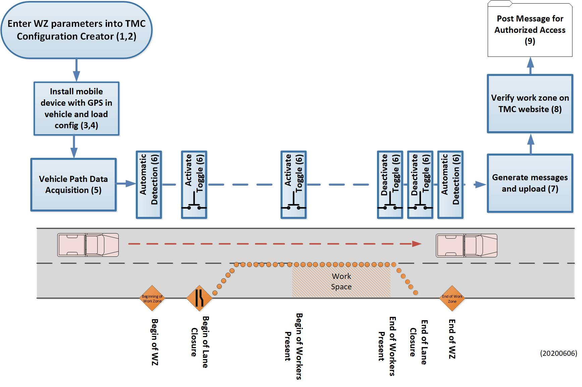

Figure 1 Illustration of WZ Mapping Toolset POC Use Case for Capturing WZ Path and Configuration Data

## WZ Mapping Toolset POC System Architecture

Figure 2 illustrates a simplified view of the of the WZ Mapping Toolset POC architecture and identifies its primary components. This architecture is adapted from the CAMP Tool architecture [5].[1] This architecture was implemented for convenience of the POC testing. Future developments are expected to revise the architecture for field applications.

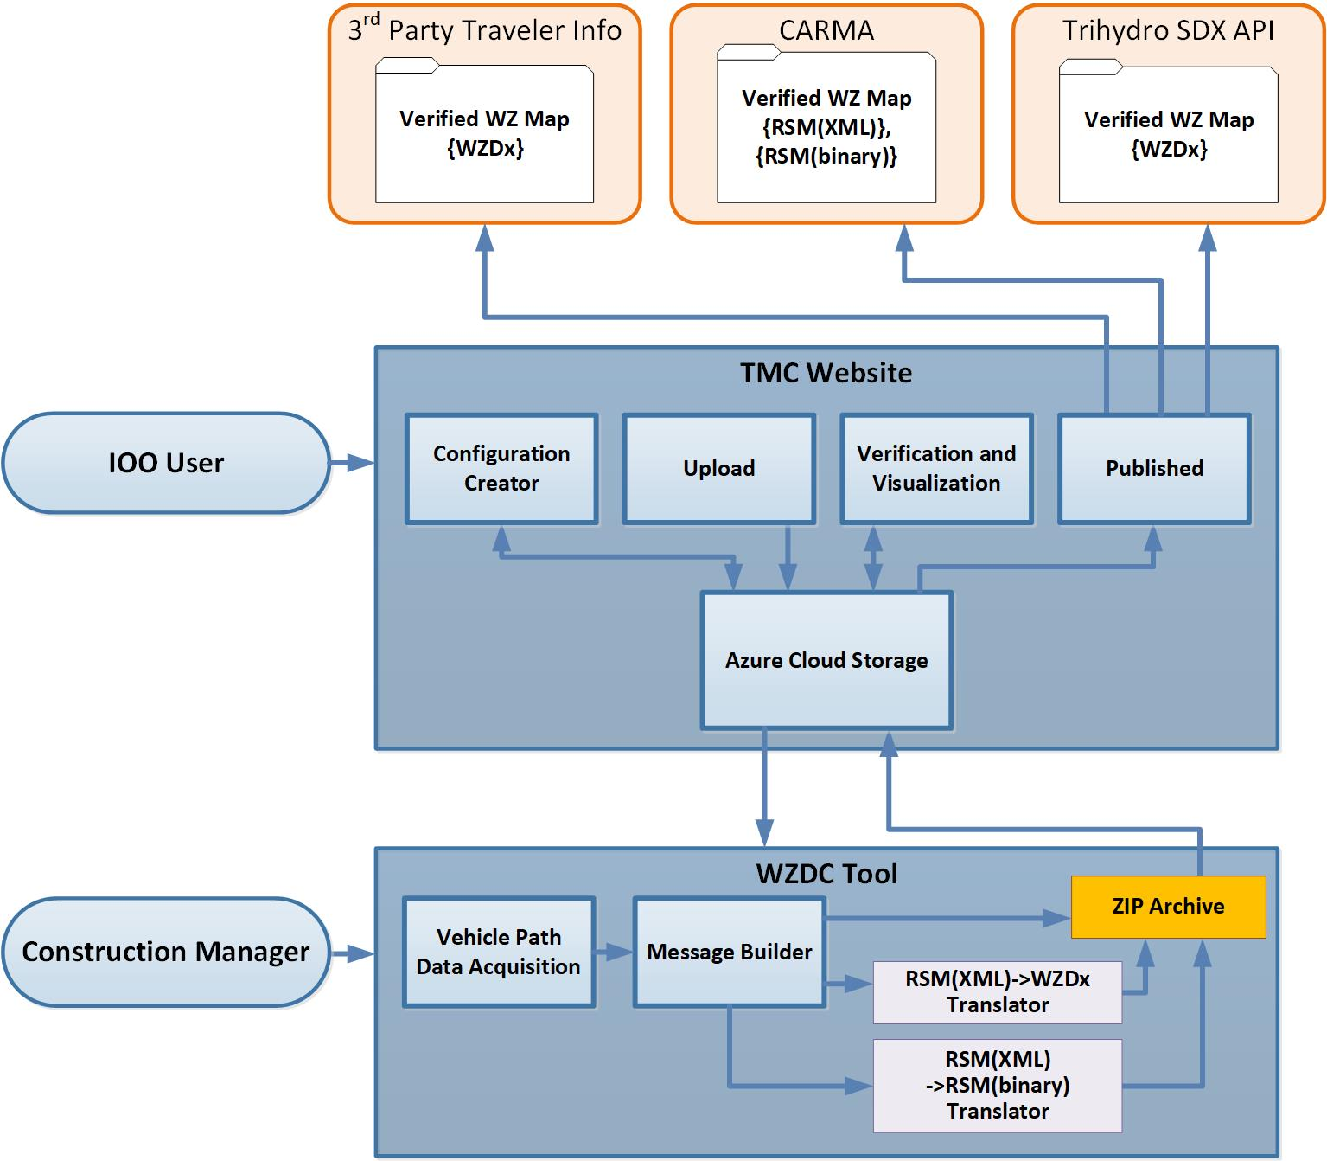

Figure 2 Illustration of the components of the POC WZ Toolset

### WZ Mapping Toolset POC System Components

The WZ Mapping Toolset POC system consists of the following two primary components, the POC Back Office TMC website [9] and the POC Work Zone Data Collection (WZDC) Tool [10].

### TMC Website

The TMC website is a C#, asp.net website that contains functional capabilities to interface with the WZDC tool. This website contains these subcomponents:

* Configuration Creator
* Upload Data Files
* Verification and Visualization
* View Published Work Zones

#### Configuration Creator

The Configuration Creator Page allows users to enter and update basic work zone configuration parameters that are used to configure subsequent data collection and to specify key parameters in work zone map messages. Work zone parameters able to be captured here include:

* Work zone text description
* Road name and/or number
* Number of lanes
* Vehicle path data lane, numbered from the left-most lane
* Average lane width
* Work Zone lane padding[2]
* Approach lane padding
* Normal speed before work zone
* Work zone speed without workers
* Work zone speed with workers
* Cause Code
* SubCause Code
* Work zone start date and time
* Work zone end date and time
* Work zone operational days of the week
* GPS location (lat / long) for the beginning and end of work zone
* Additional WZDx information:
  + Beginning Cross Street
  + Ending Cross Street
  + Begin and End mile post
  + Event Status
  + Direction
  + Accuracies – Beginning, Ending, Start Date and End Date
  + Creation Date
  + Work Types
  + Lane restrictions
  + Lane Types
  + Issuing Organization
  + WZ Location Method
  + LRS Type
  + Location Verify Method
  + Data Feed Frequency Update
  + Metadata Update Timestamp
  + Contact Name
  + Contact Email

These configuration parameters are stored in a JSON file for subsequent use by other toolset components.

#### Upload Page

The Upload Page allows a Construction Manager to upload generated work zone data ZIP archive files. This is an alternative to using the automatic upload in the WZDC tool.

#### Verification and Visualization

The Verification and Visualization Page generates two Google Earth map visualizations. The first is generated from the WZ Path & Features File, creating an object nearly identical to the J2945/4 RSM(XML) message contents. The second is created using a GeoJSON interpreter on the WZDx V2 map message. These visualizations are displayed to the user for inspection and verification. Upon approval of the message by the IOO user, the Tool stores the map messages in a designated location where they may be accessed and downloaded by authorized users. More information is provided in the Published WZ Page section below.

#### Published WZ Page

The Published WZ Page allows users, such as IOO traveler information systems, third-party traveler information systems and automated driving systems (ADS) to download published work zone messages. A user can select a work zone, the messages they want to download (WZDx, RSM(XML), RSM(binary)) and download a ZIP archive of the requested messages.

#### Azure Cloud Storage

For this POC testing the Work zone Configuration Creator and the Work Zone Map Visualization and Verification components are implemented in Azure Secured Cloud Storage containers. This storage system consists of five (5) Blob containers and an Azure Function. These five containers hold in-progress and published configuration files, work zone data ZIP archives, and unapproved and published work zone data. The Azure Function automatically unzips and moves ZIP archive files when they are uploaded.

#### Work Zone Data Collection (WZDC) Tool

The WZDC tool operates on a laptop (or other mobile device) with a high resolution GPS. It loads configuration files created from the TMC website, maps a work zone, creates messages and uploads the generated messages back to the TMC website.

#### Vehicle Path Data Acquisition

The Vehicle Path Data Acquisition component captures the latitudinal, longitudinal and elevation (lat/long/elev) coordinates of the work zone path and features, while traversing a lane adjacent to the work zone, as illustrated in the use case in Figure 3. The component automatically begins and ends data collection based off the starting and ending locations set in the configuration file. Features captured include:

* Beginning of lane closure
* Beginning of workers present
* End of workers present
* End of lane closure

POC testing staff will manually trigger recording of the GPS lat/long/elev of these features when the testing vehicle GPS antenna is adjacent and perpendicular to feature markers (e.g. barrels, cones) while traversing the testing WZ. When marking lane closures, the lane is to be marked closed when it begins to taper to closed, and the lane is to be marked open when it begins to taper to open. Vehicle path and feature data is captured in a CSV file for use by the Work Zone Message Builder.

The path that the vehicle travels is captured by the tool at 10 Hz. The message builder uses this data to generate a work zone map with concise coordinate spacing specified in J2945/1 [11].

#### Message Builder

The Message Builder component integrates information from the TMC Website Configuration Creator JSON file and the Vehicle Path Data Acquisition CSV files and generates a J2945/4 RSM work zone map message in XML format. The message builder automatically generates lane tapering around lane closures. The user only marks the beginning and end of the lane closure, and then the message builder adds tapering of the lane.

#### RSM(XML) -> WZDx Translator

The RSM(XML)->WZDx Translator component integrates information from the Work Zone Configuration Creator JSON file and the J2945/4 RSM(XML) message to generate a WZDx V2 work zone map message.

#### RSM(XML) -> RSM(binary) Translator

The RSM(XML)->RSM(binary) Translator component translates the J2945/4 RSM(XML) to generate a J2945/4 RSM work zone map message in UPER binary format.

### Optional Testing Architecture using V2X Hub

Figure 3 illustrates an optional configuration for the POC Toolset POC Testing using V2X Hub implemented on an RSU and OBU. V2X Hub is a message handler that acts as a translator and data aggregator/disseminator for infrastructure components of a connected vehicle deployment [12]. Use of the V2X Hub on an OBU and RSU enables more automated upload and download of POC WZ Toolset files.

The laptop and Azure Cloud implementations of the toolset are identical to the POC Architecture shown in Figure 2. The difference in this optional architecture is that configuration and map message files are transferred between the laptop and the cloud wirelessly via DSRC, using an RSU and an OBU, each running the V2X Hub system. Conduct of this optional feature will require implementation of enhancements to the V2X Hub by others under separate contract.

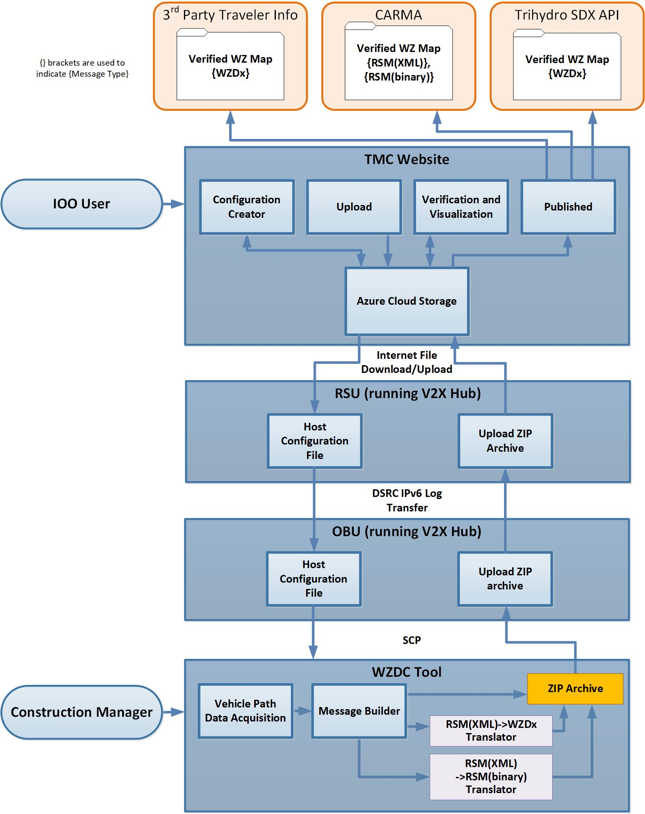

Figure 3. Illustration of Optional POC Configuration using V2X Hub.

# WZ Mapping Toolset POC Testing Requirements

As described in the introduction, the objective of Task 6 of the V2X mapping project is to develop, test and verify a proof of concept system for rapidly and efficiently capturing work zone travel path and configuration data while driving past the work zone in an adjacent lane, and for generating J2945/4 and WZDx map messages for use by third-party traveler information systems and by automated driving systems. Requirements for the POC Testing and WZ Mapping Toolset POC system are shown below. Verification of these requirements confirms proof of concept of the system. These requirements are for the WZ Mapping Toolset POC Testing only and do not represent requirements for a developmental or production system.

## Testing Requirements for Testing Work Zone

Table 1 describes the requirements for the physical testing area by specific devices, system, subsystem.

Table 1. Testing Requirements – Testing WZ

| Physical Requirements | |
| --- | --- |
| **Specific Device/System/Subsystem** | |
|  | The testing work zone shall include 1 lane, referred to as the driven lane. |
|  | The testing work zone shall include the following features:   * Beginning of WZ * Beginning of Lane Closure * Beginning of Workers Present * End of Workers Present * End of Lane Closure * End of WZ |
|  | Testing work zone features shall be indicated by visible stationary markers. |
|  | Testing work zone feature markers shall be placed adjacent to the driven lane. |
|  | Testing work zone features shall be labeled with large print labels easily read by POC Testing staff. |
|  | The location of the center of the driven lane adjacent to each feature[3] shall be determined within ±2m. |

## System Requirements

Requirements of POC WZ Mapping Toolset.

### TMC Website

Table 2 lists the testing, physical requirements for the TMC Website.

Table 2. Testing Requirements – TMC Website.

| Physical Requirements | |
| --- | --- |
| **Specific Device/System/Subsystem** | |
|  | The TMC website shall include a user interface component for manual entry of work zone configuration data, labeled below as the TMC Configuration Creator. |
|  | TMC Configuration Creator user interface shall allow input of the following fields:   * Work Zone Text Description * Number of lanes * Vehicle Path Data Lane, numbered from the left-most lane * Average Lane Width * WZ lane padding * Approach lane padding * Cause Code * SubCause Code * Work Zone Start Date and Time * Work Zone End Date and Time * Work Zone Operational Days of the Week * GPS location (latitude / longitude) for the beginning and end of work zone[4] * Beginning Cross Street * Ending Cross Street * Event Status * Direction * Accuracies – Beginning, Ending, Start Date and End Date * Work Types * Lane restrictions * Lane Types * Normal Speed before work zone * Work Zone Speed without workers * Work Zone speed with workers * Issuing Organization * WZ Location Method * LRS Type * Location Verify Method * Data Feed Frequency Update * Contact Name * Contact Email |
|  | The TMC Configuration Creator shall store configuration data in a JSON file. |
|  | The TMC Configuration Creator shall save configuration files in cloud storage. |
|  | The TMC Configuration Creator shall import configuration files (to the user interface) from cloud storage. |
|  | The TMC Configuration Creator shall publish configuration files to cloud storage for use by other components. |
|  | The TMC Configuration Creator shall be capable of downloading configuration files to a user’s computer. |
|  | The TMC website shall include a component for uploading mapped work zone ZIP archives. This will be referred to as the TMC Upload component |
|  | The TMC Upload component shall enable a user to upload work zone ZIP archives to cloud storage. |
|  | The TMC website shall unzip uploaded work zone data ZIP archives. |
|  | The TMC website shall organize uploaded work zone ZIP archives into labeled sub-folders. |
|  | The TMC website shall include a component for verifying and visualizing mapped work zones. This will be referred to as the TMC Verification and Visualization component. |
|  | The TMC Verification and Visualization component shall display a visualization of the mapped work zone. |
|  | The visualization shall overlay work zone information (described in PRT-13.2,3,4,5) on a satellite image of the roadway. |
|  | The visualization shall display markers for each of the following work zone features:   * Start of lane closure * End of lane closure * Start of worker presence * End of worker presence |
|  | The visualization shall display the recorded vehicle path. |
|  | The visualization shall display the GPS locations of feature markers. |
|  | The visualization shall display the GPS locations of vehicle path points. |
|  | The TMC Verification and Visualization component shall display a visualization of the WZDx message for inspection. |
|  | The visualization shall overlay WZDx work zone information on a satellite image of the roadway. |
|  | The visualization shall display location-based properties of the WZDx message. |
|  | The TMC Verification and Visualization component shall allow a user to publish an approved work zone for dissemination. |
|  | The TMC website shall include a page for downloading published work zone data, labeled below as the TMC Published Page. |
|  | The TMC Published Page shall allow an authorized external party to download any of the 3 published work zone messages. These messages include:   * WZDx * RSM (XML) * RSM (binary) |

### WZDC Tool

Table 3 lists the physical requirements for testing the WZDC tool.

Table 3. Testing Requirements – WZDC Tool

| Physical Requirements | |
| --- | --- |
| **Specific Device/System/Subsystem** | |
|  | The WZDC tool shall run on a laptop or other portable computing device. |
|  | The WZDC tool shall download Configuration files from the TMC website. |
|  | The WZDC tool shall import Configuration files. |
|  | The WZDC tool shall interface with a GPS over USB. |
|  | The WZDC tool shall include a component capable of collecting work zone data referred to below as the Vehicle Path Data Acquisition (VPDA) component. |
|  | The VPDA component shall record the following data elements at 10Hz:   * Timestamps * Latitude * Longitude * Altitude * Speed * Heading * Feature markers/values for: * Beginning of work zone * Beginning of lane closure * Beginning of worker presence * Ending of worker presence * Ending of lane closure * Ending of work zone |
|  | The VPDA component shall automatically begin data collection[5] 50 meters before the beginning of the work zone (location set in configuration file). |
|  | The VPDA component shall automatically mark the reference point[6] at the beginning of the work zone (location set in configuration file). |
|  | The VPDA component shall allow a user to mark locations of work zone features including:   * Beginning of Lane Closure * Beginning of Workers Present * End of Workers Present * End of Lane Closure |
|  | The VPDA component shall record locations of user marked features. |
|  | The VPDA component shall automatically terminate data collection at the end of the work zone (location set in configuration file). |
|  | The VPDA component shall generate a WZ Path and Features file, containing all the data elements that were recorded during data collection. |
|  | The VPDA component shall generate lane tapers surrounding lane closures/openings. |
|  | The length of lane tapers shall be within ±10% of the merging taper length defined in [**13** (Table 6C-4[7])], unless inhibited[8]. |
|  | Lane tapers will appear at the beginning of every lane closure, beginning at the user-marked beginning of lane closure feature. |
|  | Lane tapers will appear at the end of every lane closure, beginning at the user-marked end of lane closure feature. |
|  | The VPDA component shall generate RSM (XML) files in accordance with SAE J2945/4[9]. |
|  | The VPDA component shall generate RSM (binary) files in accordance with SAE J2945/4[10]. |
|  | The VPDA component shall generate WZDx v2.0 files in accordance with (GitHub). |
|  | The recorded locations of work zone features shall be accurate to within ± 8m of the independently measured feature locations. |
|  | The WZDC tool shall generate a ZIP archive containing the following files:   * Configuration file (JSON) * WZ Path and Features file (CSV) * RSM (XML) file(s) (XML) * RSM (binary) file(s) (UPER) * WZDx file (GeoJSON) |
|  | The WZDC tool shall upload a generated ZIP archive to cloud storage when requested be a user. |
|  | The upload cloud storage location shall be accessible by the TMC website. |

### Authentication and security

This solution is a proof of concept and has no user/group authentication within it. This component can be added for secure access and specific group authentication. Currently, information is stored within a file storage container with no verification of user or group.

### Optional V2X Hub Addition

This is an optional component, and many of the details have not yet been determined, as this is not in the scope of this project. This addition may be implemented in future contracts.

The V2X Hub will monitor the cloud for changes, and when a new configuration file is created in the cloud, it will be downloaded to the V2X Hub. RSUs will then download these files. OBUs watch for new files being hosted by RSUs, and new files available to the laptop running the

WZDC tool. Table 4 lists the testing requirement for the optional V2X Hub.

Table 4. Testing Requirements – Optional V2X Hub

| Physical Requirements | |
| --- | --- |
| **Specific Device/System/Subsystem** | |
|  | Connected Vehicle Roadside Unit (RSU[11]) shall be connected to the backhaul network from roadside cabinets. |

# WZ Mapping Toolset POC Agile Development Sprint

This software application follows the Agile methodology. We execute sprints every 2 weeks and track features and issues within the Atlassian Jira software—see Table 5 for development lifecycle. Within our Jira board, we maintain a backlog of new features and improvements for the entire solution.

Table 5. Feature and Development Lifecycle

|  |  |  |
| --- | --- | --- |
| Date | * Description | |
| 4/27/20 | * Read and write as JSON object for configuration file * Added user notification to website * Added lat/long/road name fields to config file * Upload and store configuration within Azure file storage * Added map visualizer * Full end to end test |
| 5/11/20 | * Push publish work zone * Auto unzip functionality * Improved visualizations for work zone * Added navigation bar * Changed configuration creator ui to include tabs * Added required validation for fields * In-progress and published functionality * Search functionality on map * Integration Azure Cloud connection – download/upload * Adjusted version requirements for Java of Binary(uper) converter |
| 5/25/20 | * Improved Visuals on website * Added new fields to config file for WZDx message * Improved error catching * Upgraded GPS data compression in message generation * Added additional information in WZDx message * Updated GPS serial port search |

# 

# WZ Mapping Toolset POC Demonstration and Testing Plan

## Introduction

This section of the report describes a plan for testing of the proof of concept of the WZ Mapping Toolset. This section is organized as follows:

* Demonstration Summary
* Testing Summary
* Testing Objective
* Testing Approach
* Testing Environment
* Roles and Responsibilities
* Testing Preconditions
* Testing Schedule
* Features for Testing
* Testing Equipment
* Safety Requirements
* Testing Procedure

## Demonstration Summary

The POC WZ Toolset was implemented by the ICF team and was demonstrated to FHWA TOCOR and designated parties. While the primary choice for demonstration was the FHWA Turner Fairbank Highway Research Center (TFHRC), this was prevented by COVID-19 restrictions on travel and gatherings. Instead, a live work zone in Cheyenne, WY, near the intersection of I-25 and I-80 was used. The demonstration was conducted in partnership with WYDOT on July 9th, 2020, in which all components of the toolset were demonstrated and explained, and the live work zone was mapped.

## Testing Summary

The POC WZ Toolset testing was conducted at a shooting complex in Cheyenne, WY. The testing was conducted on June 24th, 2020 on a simple, artificial work zone, where a series of drive tests were recorded for presentation to FHWA and interested parties. The testing was a success, and all of the results of testing are described in the accompanying Testing Results document, including the testing plan and steps within the tests procedure.

## Testing Objective

The objective of the POC testing is to evaluate and verify the functionality and performance of a POC system, which captures lat/long/elev of work zone configuration, travel path and features and generates an accurate work zone map message in each of three formats that can be published to share with IOO traveler information systems and with the ADS. The three map message formats are WZDx V2[1]**,** SAE J2945/4 RSM (XML)[4], and SAE J2945/4 RSM (binary)[4]. The POC is proved through the verification of POC Testing Requirements defined in Chapter 3.

## Testing Approach

The Proof of Concept procedure is specified below in Section 5.13. This procedure verifies each of the WZ Mapping Toolset components described in Section 2.2.1 and verifies each of the POC Test Plan Requirements from Chapter 3.

## Testing Environment

The POC WZ Toolset testing was completed at the Laramie County Shooting Sports Complex in Cheyenne, WY. The work zone was artificially created using signs placed at intersections.

## Roles and Responsibilities

The POC WZ Toolset testing was conducted by the Neaera Team and the lead testing engineer will be Tony English of Neaera Consulting. He was supported by Neaera Consulting and ICF staff.

The testing will be reviewed by FHWA TOCOR Deb Curtis, and technical assistance staff from Noblis.

## Testing Preconditions

The preconditions for conducting this testing were:

* Completion of development and initial testing of all components of the WZ Mapping Toolset for POC Testing.
* Prior successful completion of the testing procedure described in section V.10 below by the project team.
* Verification that, prior to testing, GPS accuracy of the system is within ±2m.
* Acceptance by the FHWA TOCOR of the testing site and testing strategy.

## Testing Schedule

The WZ POC Testing was conducted on June 24th, 2020.

## Features for Testing

The key features of the Integrated WZ Mapping Toolset POC system tested include:

* Work Zone Configuration Creator Page
* Work Zone Data Collection Tool
* Vehicle Path Data Acquisition Component
* Work Zone Map Builder Component
* RSM(XML)->WZDx Translator Component
* RSM(XML)->RSM(binary) Translator Component
* WZ Map Verification and Visualization Page
* Published WZ Page containing WZDx V2.0, SAE J2945/4 RSM (XML), and SAE J2945/4 RSM (binary) work zone map messages for dissemination to IOO traveler information systems and to automated driving systems.

## Testing Equipment

Components of the WZ Mapping Toolset, described in Section 2.2.1 are implemented in the Azure Cloud and on a laptop with high resolution GPS. The testing will be conducted on a roadway with two lanes. Traffic cones will be used to indicate the beginning and end of work zone features.

## Safety Requirements

Neaera Consulting and ICF Team are required to confirm that all safety procedures and safety requirements required for the testing site are met.

Special precautions are necessary to comply with COVID-19 safety requirements and guidelines, including wearing of masks and maintaining at least 6 feet personal separation distance.

## Testing Procedure

Table 6 presents the procedure for Testing of the WZ Mapping Toolset POC System.

Table 6. Testing Procedure

|  |  |  |  |  |
| --- | --- | --- | --- | --- |
| Step | Activity | Action | Expected Result | Testing Requirements Verified |
| **Initialize and prepare for Testing** | | | | |
| 1 | Initialize Back Office Folders | Empty Back Office File Folders including   * WZ Config {JSON} & WZ Map {RSM(XML)}, {RSM(binary)}, WZ Path & Features, and {WZDx} (Unzipped) File Folder * Verified WZ Map {RSM(XML)}, {RSM(binary)}, and {WZDx} File Folder | File folder inspection shows file folders are empty |  |
| 2 | Initialize Laptop Application and Folders | Initialize Laptop Work Zone Data Collection Application  Empty Laptop File Folders including   * WZ Config {JSON} & WZ Path & Features {CSV} File Folder * WZ Config {JSON} & WZ Map {RSM(XML)}, {RSM(binary)}, WZ Path & Features, and {WZDx} File Folder (Zipped) File Folder | Application open and ready for input  File folder inspection shows file folders are empty |  |
| 3 | Prepare Testing WZ track | Set up Testing WZ including Cone Placement for   * Begin of WZ * Begin of Lane Closure * Begin of Workers Present * End of Workers Present * End of Lane Closure * End of WZ   Independently measure Lat/Long of work zone features within +/- 2m accuracy of   * Begin of WZ * Begin of Lane Closure * Begin of Workers Present * End of Workers Present * End of Lane Closure * End of WZ | Testing WZ is setup, measured, and ready for testing. | PRD-01, PRD-02, PRD-03, PRD-04, PRD-05, PRD-06 |
| **Conduct Testing** | | | | |
| 4 | Test TMC Configuration Creator | Test Engineer opens TMC Configuration Creator page and verifies entry of each parameter.  Upon completion, WZ Config {JSON} file is saved and published to Azure cloud storage and downloaded to designated file folder.  Test Engineer opens and displays WZ Config file using file inspection tool.  Test engineer shows that WZ configuration parameters are correct. | Testing of Configuration Creator, including the following fields:   * Work Zone Description * Number of lanes * Vehicle Path Data Lane * Average Lane Width * Normal speed (before work zone) * Work Zone Speed without workers * Work Zone speed with workers * Work Zone Type * Start Date and Time * End Date and Time * Days of the Week in operation * GPS location (latitude / longitude) for the beginning and end of work zone   Entry of additional WZDx information:   * Beginning Cross Street * Ending Cross Street * Event Status * Road Direction * Accuracies – Beginning, Ending, Start Date and End Date * Work Types * Lane restrictions * Lane Types * Issuing Organization * WZ Location Method * LRS Type * Location Verify Method * Data Feed Frequency Update * Contact Name * Contact Email | PRT-01, PRT-02, PRT-03, PRT-04, PRT-06, PRT-07 |
| 5 | Setup Laptop and WZ Path Application in Vehicle | Test engineer sets up laptop in vehicle, connecting GPS antenna and power as needed.  Test engineer initiates WZDC application and verifies application is receiving valid GPS coordinates.  Test engineer loads configuration file into WZDC application and verifies it has loaded the configuration file.  Test engineer presses “Begin Data Collection” and verifies the application is ready to capture data. | WZDC application and vehicle are ready for data collection. | PRW-01, PRW-02, PRW-03, PRW-04  PRT-02, PRT-03, PRT-04 |
| 6 | Confirm track is clear and all equipment and participants are ready to safely conduct testing. | Driver confirms Testing WZ track is clear and testing is ready to proceed.  Driver starts vehicle.  Driver confirms all parties are ready to begin and all participants agree testing can be performed safely. | Track and all participants are ready for data collection and ready for vehicle to traverse the Testing WZ. |  |
| **Vehicle Path Data Collection** | | | | |
| 7 | Driver traverses testing WZ path | Driver begins traversing the specified path adjacent to the work zone, accelerating to and holding 15 mph, adhering to the middle of the lane as much as practical.  Driver continues to end of Testing WZ and stops vehicle. | Vehicle containing testing participants traverses the testing WZ. |  |
| 8 | Test Engineer captures WZ path and features while traversing WZ path | While traversing the specified path adjacent to the work zone, the test engineer shows that the application automatically completes the following steps:   * Data collection begins * Reference point is marked * Data collection ends   While traversing the specified path adjacent to the work zone, the test engineer toggles the WZDC Vehicle Path Data Acquisition application controls when perpendicular to each of the following:   * Begin of Lane Closure * Begin of Workers Present * End of Workers Present * End of Lane Closure | Data collection begins ~50m before the Begin of WZ marker  Reference point is marked when roughly perpendicular to Begin of WZ  Data collection ends when roughly perpendicular to End of WZ  WZ Vehicle Path Data Acquisition Application captures path and feature lat/long data. | PRW-05, PRW-07, PRW-08, PRW-09, PRW-11 |
| **Data and Map Message Assessment** | | | | |
| 9 | Inspection of WZ Path & Features file | Upon completion of the WZ Testing run  Test engineer verifies that the WZ Path & Features {CSV} file is located in the designated laptop file folder.  Test engineer opens and displays WZ Path & Features {CSV)} file using file inspection tool.  Test engineer shows that WZ path and features lat/long are collected.  (accuracy is verified in Step 10) | WZ Path & Features File located in the specified laptop folder.  Inspection of the WZ Path & Features file verifies that WZ path and features parameters were collected and stored in a CSV file. | PRW-06, PRW-10, PRW-12 |
| 10 | Verify WZDC message builder. Inspect WZ Map {RSM(XML)} File., | Test engineer verifies that the WZ Map {RSM(XML)} File is in the designated laptop folder.  Test Engineer opens and inspects WZ Map {RSM(XML)} File using file inspection tool.  Test engineer verifies that WZ map path and features lat/long are captured.  Test engineer analyzes results and shows that WZ map features (and lane tapers) lat/long are within specified tolerances. | WZ Map {RSM(XML)} file is located in the specified laptop folder.  Inspection verifies that WZ map path and features lat/long were collected and stored in an RSM(XML) file.  Analysis verifies that WZ map features (and lane tapers) lat/long are within acceptable tolerances. | PRW-13, PRW-13.1, PRW-13.2, PRW-13.3, PRW-14, PRW-17 |
| 11 | Verify RSM(XML)->WZDx Translator. Verify RSM(XML)-> {RSM(binary)} Translator. | Test engineer verifies that the WZ Map {WZDx} file is located in the designated laptop file folder.  Test engineer verifies that the WZ Map {RSM(binary)} file is located in the designated laptop file folder.  Test Engineer opens and displays WZ Map {WZDx} File using file inspection tool.  Test engineer shows that WZ path and features parameters are consistent with WZ Map {RSM(XML)} file. | WZ Map {WZDx and RSM (binary)} files are located in the specified laptop folder.  Inspection verifies that WZ path and features parameters were collected and stored in WZDx file. | PRW-15, PRW-16 |
| 12 | Verify work zone data ZIP archive contents. | Test engineer verifies that the ZIP archive is located in the specified laptop directory.  Test engineer unzips local zip file and shows that all of the files are present. | Inspection shows that WZ Config, WZ Path & Features, WZ Map {RSM(XML)}, {RSM(binary)} & {WZDx} are present in the local unzipped archive. | PRW-18 |
| 13 | Trigger WZDC tool to upload files to Back Office. | Test engineer presses “Upload” on the WZDC application and verifies that the application displays a success message.  Test engineer verifies that the ZIP archive is located in cloud storage.  Test engineer verifies that messages and files are organized in cloud storage. | Inspection shows that WZ Config, WZ Path & Features, WZ Map {RSM(XML)}, {RSM(binary)} & {WZDx} are uploaded and stored in the designated Back Office File folder (unzipped). | PRW-19, PRW-20  PRT-10, PRT-11 |
| 14 | Test TMC Website Visualizer. | Test engineer activates the TMC Visualization and Verification application and loads the work zone.  Test Engineer displays the WZ Map {RSM(XML)} & {WZDx} files to the independently measured lat/long and to the satellite map of the Testing WZ.  Test Engineer verifies that the WZ Map {RSM(XML)} & {WZDx} files correctly depict   * Begin of WZ * Begin of Lane Closure * Begin of Workers Present * End of Workers Present * End of Lane Closure * End of WZ   Test Engineer verifies approval feature of application and storage of files in designated Back Office File Folder.  Test Engineer opens, displays and confirms transfer of each of the WZ Map Files using file inspection tool. | Inspection confirms that verified WZ Map {RSM(XML)} & {WZDx} are stored in the designated Back Office File folder, ready for download by others. | PRT-12, PRT-13, PRT-13.1, PRT-13.2, PRT-13.3, PRT-13.4, PRT-13.5, PRT-14, PRT-14.1, PRT-14.2, PRT-15, PRT-16 |
| 15 | Test availability of WZ Map {RSM(XML)} and WZ Map {WZDx} Files Third party traveler information services and for CARMA systems. | Test Engineer inspects file folders and shows WZ Map {RSM(XML)}, {RSM(binary)}, and {WZDx} Files are available for access by simulated Third party traveler information services and for CARMA systems.  Test Engineer downloads all 3 messages and verifies the contents of the download ZIP archive using a file inspection tool. | Downloaded ZIP archive contains all 3 messages | PRT-17 |

# Glossary

Table 7 lists the glossary of acronyms used in this document.

Table 7. Glossary

|  |  |
| --- | --- |
| Acronym | Definition |
| ADS | Automated driving systems |
| DSRC | Dedicated Short Range Communications |
| FHWA | Federal Highway Administration |
| IOO | Infrastructure Owners and Operators |
| ITS JPO | Intelligent Transportation Systems Joint Program Office |
| lat/long/elev | Latitude, longitude, and elevation |
| POC | Proof of Concept |
| TFHRC | Turner Fairbank Highway Research Center |
| TMC | Transportation Management Center |
| TOCOR | Task Order Contracting Officer's Representative |
| TTC | Temporary traffic control |
| WZDx | Work Zone Data Exchange |
| WZED | Work Zone Event Data |
| WZDC | Work Zone Data Collection (tool) |
| WZDI | Work Zone Data Initiative |
| XML | Extensible markup language |

# References

Table 8 lists the documents, sources and tools used and referenced to develop the concepts in this document.

Table 8. References

|  |  |
| --- | --- |
| # | Document (Title, source, version, date, location) |
| 1 | *Work Zone Data Exchange (WZDx) v2 Specification*, Federal Highway Administration (FHWA) and Intelligent Transportation Systems Joint Program Office (IT'S JPO), Jan 14, 2020.  <https://github.com/usdot-jpo-ode/jpo-wzdx/> |
| 2 | Work Zone Data Initiative (WZDI), Federal Highway Administration (FHWA).  <https://collaboration.fhwa.dot.gov/wzmp/wzdi/Forms/AllItems.aspx> |
| 3 | *Work Zone Event Data (WZED) – Data Dictionary Report,* Federal Highway Administration (FHWA), Version 3, Feb 28,2020.  <https://collaboration.fhwa.dot.gov/wzmp/Data%20DictionaryDocuments/Forms/AllItems.aspx> |
| 4 | SAE J2945/4 – Road Safety Applications – UNPUBLISHED  <http://standards.sae.org/j2945/1_201603/> |
| 5 | V2I Safety Applications, Connected Work Zone Software Toolchain User Guide CAMP LLC Vehicle to Infrastructure Consortium, *Version 1.1*, September 3, 2019.  <https://www.campllc.org/download-software-tools/> |
| 6 | *Task 2 Technical Memo – Compiled Report*, Infrastructure and V2X Mapping Needs Assessment and Development Support Project, ICF Draft Report to Federal Highway Administration (FHWA), |
| 7 | *Task 3 Stakeholder Outreach Memo*, Infrastructure and V2X Mapping Needs Assessment and Development Support Project, ICF Draft Report to Federal Highway Administration (FHWA). |
| 8 | Design and Evaluation of a Connected Work Zone Hazard Detection and Communication System for Connected and Automated Vehicles (CAVs), Office of the Secretary of Transportation (OST), USDOT, Final Report, August 2019.  <https://www.vtti.vt.edu/utc/safe-d/wp-content/uploads/2019/10/03-050_FinalResearchReport_Final.pdf> |
| 9 | *POC TMC Website*, Proof-of-Concept of Integrated Work Zone Mapping Toolset Project, Federal Highway Administration (FHWA).  <https://github.com/TonyEnglish/V2X-manual-data-collection> |
| 10 | *POC Work Zone Data Collection Tool*, Proof-of-Concept of Integrated Work Zone Mapping Toolset Project, Federal Highway Administration (FHWA).  <https://github.com/TonyEnglish/V2X-manual-data-collection/tree/master/Work%20Zone%20Data%20Collection%20Tool> |
| 11 | SAE J2945/1_201603 - On-Board System Requirements for V2V Safety Communications, SAE International, March 30, 2016.  <http://standards.sae.org/j2945/1_201603/> |
| 12 | *V2X Hub*, Federal Highway Administration (FHWA).  <https://github.com/usdot-fhwa-OPS/V2X-Hub> |
| 13 | Manual on Uniform Traffic Control Devices (USDOT).  <https://mutcd.fhwa.dot.gov/htm/2009/part6/part6c.htm> |

U.S. Department of Transportation

ITS Joint Program Office – HOIT

1200 New Jersey Avenue, SE

Washington, DC 20590

Toll-Free “Help Line” 866-367-7487

[www.its.dot.gov](http://www.its.dot.gov)

FHWA-JPO-20-815



1. While the initial implementation of the WZ Mapping Toolset for POC heavily leveraged the components and code from the CAMP tool, the core code was replaced over time as needs for the POC system evolved. The WZ Mapping Toolset represents many new components of the code base.
2. Lane padding describes any additional width of a work zone or approach region lane relative to the normal (average) lane width.
3. This will be used as the location of the feature in calculations.
4. These locations are used to start data collection, mark the reference point, and end data collection (PRW-07,08,11)
5. The beginning of data collection begins the approach region for the RSM message.
6. The reference point represents the start of the work zone (Beginning of WZ feature).
7. The normal roadway speed is used as the posted speed limit.
8. Length of lane closure is shorter than taper length.
9. This standard has not yet been published. Until the standard is published, the RSM (xml) messages generated will match the CAMP tool’s RSM (xml) message format.
10. This standard has not yet been published. Until the standard is published, the RSM (binary) messages generated will match the CAMP tool’s RSM (binary) message format.
11. Roadside Units (RSUs) represent the package of DSRC radios, computing, communications that will be installed on a roadside.